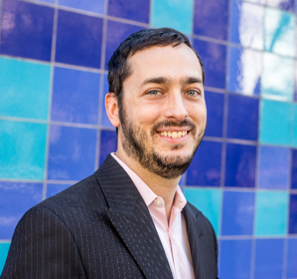
Michael GARNER
London, UK • ‭+44 7304 274651‬ • m@garner.art

Exhibitions

GAIA Gallery, New York City Oct. 2024

White Conduit Projects, Lions and Unicorns: RCA Alumni, London Feb. 2025

The Bomb Factory, Past Lives, Present Futures, London March 2025

Royal College of Art, Degree exhibition, London June 2025

The Bomb Factory, Most Experiments End in Failure, London (solo show) June-July 2025

Publications and Appearances

My Life as a CIA Spy: I Was Never a CIA Spy (book) Aug. 2024

The Dodo, On The Buddhist Concept of Emptiness Nov. 2024

Podcast Interview, Spies, Lies, and Private Eyes Jan. 2025

Independent Film Festival, Finch Films May 2025

Education

Royal College of Art, London, UK
- MA Candidate in Contemporary Art Practice, 2025. Served as student representative for the programme.
- Offered the President and Vice-Chancellor’s International Scholarship

The George Washington University, Elliott School of International Affairs, Washington, D.C., USA
Recipient of a Merit Fellowship as well as a Foreign Language and Area Studies Fellowship, with full tuition and a stipend.
- MA in International Affairs and Development, 2009.

The University of Texas, Austin, TX, USA
- BA with Honors in Sociology; Minor in Linguistics, 2003.

Professional Experience

Development Seed, Product Manager 2022–2023
- Proposed and coordinated a redesign for a NASA GIS research project to greatly increase the usability and function of the site in line with user feedback. Worked closely with UX/UI designers.
- Facilitated Agile ceremonies; coached the team on Agile best practices and remove blockers. Employed empathy and listening skills as well as deep self awareness.

Honors & Achievements
- 2012 Exceptional Performance Award, U.S. Government
- 2009-10 Presidential Management Fellow (PMF) finalist.
- 2008-09 Foreign Language and Area Studies (FLAS) Fellow; full tuition and stipend.
- 2008 (April and June) Certificate of Appreciation, U.S. Department of State.
- 2007-08 Merit Fellow, The George Washington University.
- 2006-07 Taiwan Scholarship recipient; full tuition and stipend.
- 2004 Research Experience for Undergraduates (REU) participant.

Professional Skills and Certifications

- Languages: English (native); Spanish (C1); Mandarin Chinese (B1); French (A2); Russian (A1)
- Project Management: Project Management Professional (PMP) from PMI

